As-Is

Actor | Activity
User | Purchases item
Financial Institution | Provides account statements
User | Manually collects data from account statements (if at all)
 | Enters expenses manually into spreadsheet or notebook
 | Reviews data (typically at certain intervals throughout the week or month, if at all)
Support Resources | Consulted for budgeting advice(blogs, advisors, etc.)
User | Adjusts behavior after review
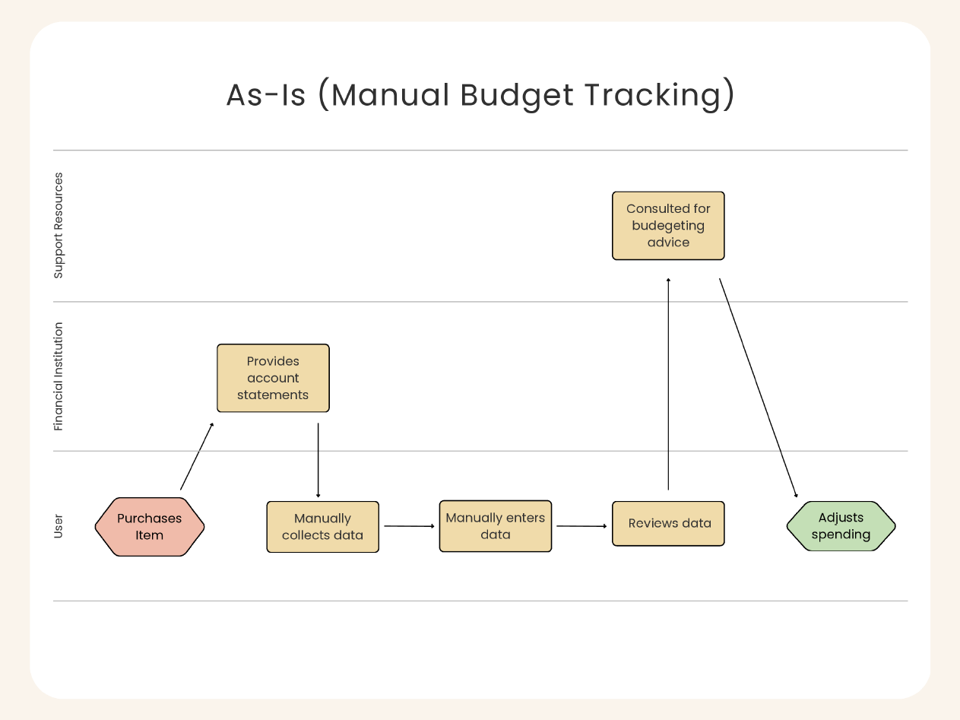

To-Be

Actor | Activity
User | Purchases item
 | Logs into SmartBudget (process initiation)
SmartBudget | Pulls/receives data (manual input or automatic sync)
Financial Institution | Sync updates expense data, if connected
SmartBudget | Automatically categorizes and visualizes (through rules, updates made in real-time)
 | Monitors spending pattern (compares real-time data to set budget)
 | Provides Tips or Alerts (notifies for overspending or actionable advice)
User | Proactively reacts to adjust spending before overspending occurs
